# Worksheet on Unit -2

Perform left-factoring and /or elimination of left recursion to transform each of the below ten grammars into a form which is suitable for recursive descent parsing. In the resultant grammar (after eliminating left recursion and performing left factoring), perform recursive descent parsing for any valid string of your choice.

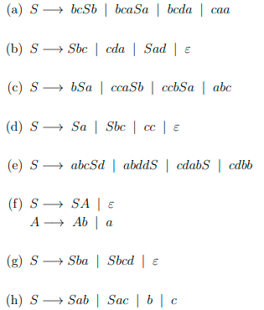

(i)

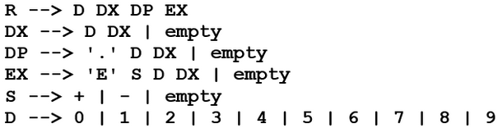

(J) A -> abB | aB | cdg | cdeB | Acd | AfB; B -> BbaA | ba

(K) A -> ad | a | Aab | Aabc | b

(L) S -> SiEtS | SiEtSeS | a; E -> b

Find the FIRST and FOLLOW o

f every nonterminal in each of the following five grammars

